Your Club Name

COVID-19 SELF-DECLARATION
FOR MEMBERS AND VISITORS ON ARRIVAL

Scan with your phone to fill in ONLINE
The health and well-being of our staff and players is our highest priority. As a result of COVID-19 outbreak, we are applying screening processes and hygiene measures to safeguard users to our premises and the bridge community.
Please place your QR code here if you have an online sign in form
On entry to the premises, please sanitise hands with the sanitiser provided. Entry to the kitchen is limited to staff unless escorted.
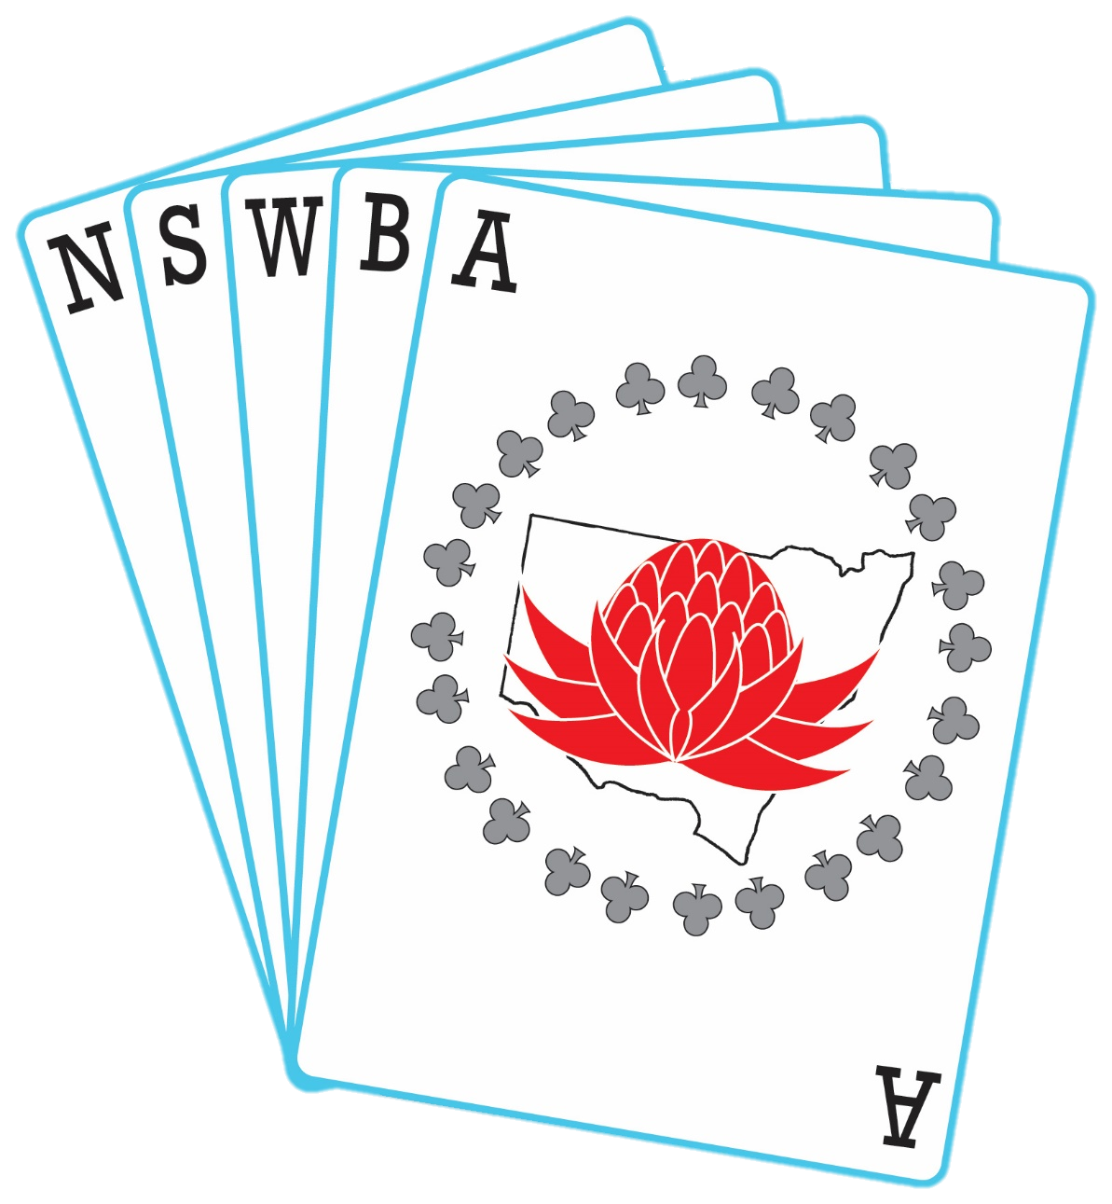
As a condition of entry to the premises, please answer the questions below and adhere to the additional hygiene processes we have on our site.
SELF-DECLARATION | YES / NO
Are you presenting any of the following symptoms relating to COVID-19?
- Fever
- Cough
- Sore throat
- Shortness of breath
- Persistent pain in the chest
Have you recently been in contact with someone diagnosed with coronavirus to your knowledge?
Have you recently travelled outside Australia in the last 2 weeks?
Do you suffer from compromised immunity, chronic medical conditions?
If you respond ‘YES’ to any of these questions, then as a precautionary measure, you will be unable to visit our premises today.
We ask for your full support as we all have a shared responsibility to minimise the risk of exposure and protect our individual and collective health.
Self-declaration records will be used and disclosed for managing site access during the risk period only and as required by law. Records will be kept securely and retained for a period required under our retention schedules in compliance with privacy laws and regulations.
I acknowledge that the information I have given is accurate and complete.
ASSUMPTION OF THE RISK AND WAIVER OF LIABILITY RELATING TO CORONAVIRUS / COVID-19
Sydney Bridge Centre (“the Club”) has put in place preventative measures to reduce the spread of COVID-19; however the Club cannot guarantee that you will not become infected with COVID-19. Further, attending the Club could increase your risk of contracting COVID-19.
By signing this agreement, I acknowledge the contagious nature of COVID-19 and voluntarily assume the risk that I may be exposed to or infected by COVID-19 by me attending the Club and that such exposure or infection may result in my personal injury, illness, permanent disability, and death. I understand that the risk of becoming exposed to or infected by COVID-19 at the Club may result from the actions, omissions, or negligence or myself and others, including, but not limited to, Club employees, volunteers, and bridge players & their families.
I voluntarily agree to assume all of the foregoing risks and accept sole responsibility for any injury to myself (including, but not limited to, personal injury, disability, and death), illness, damage, loss, claim, liability, or expense, of any kind, that I may experience or incur in connection with my attendance at the Club or participation in Club programming (“Claims”). On my behalf, I hereby release, covenant not to sue, discharge, and hold harmless the Club, its employees, agents, and representatives, of and from the Claims, including all liabilities, claims, actions, damages, costs or expenses of any kind arising out of or relating thereto. I understand and agree that this release includes any Claims based on the actions, omissions, or negligence of the Club, its employees, agents, and representatives, whether a COVID-19 infection occurs before, during, or after participation in any Club program.
NAME
EMAIL |  | MOBILE
SIGNATURE |  | DATE
One form must be completed for every person in the premises.

